**Niskayuna Fire District No. 1**

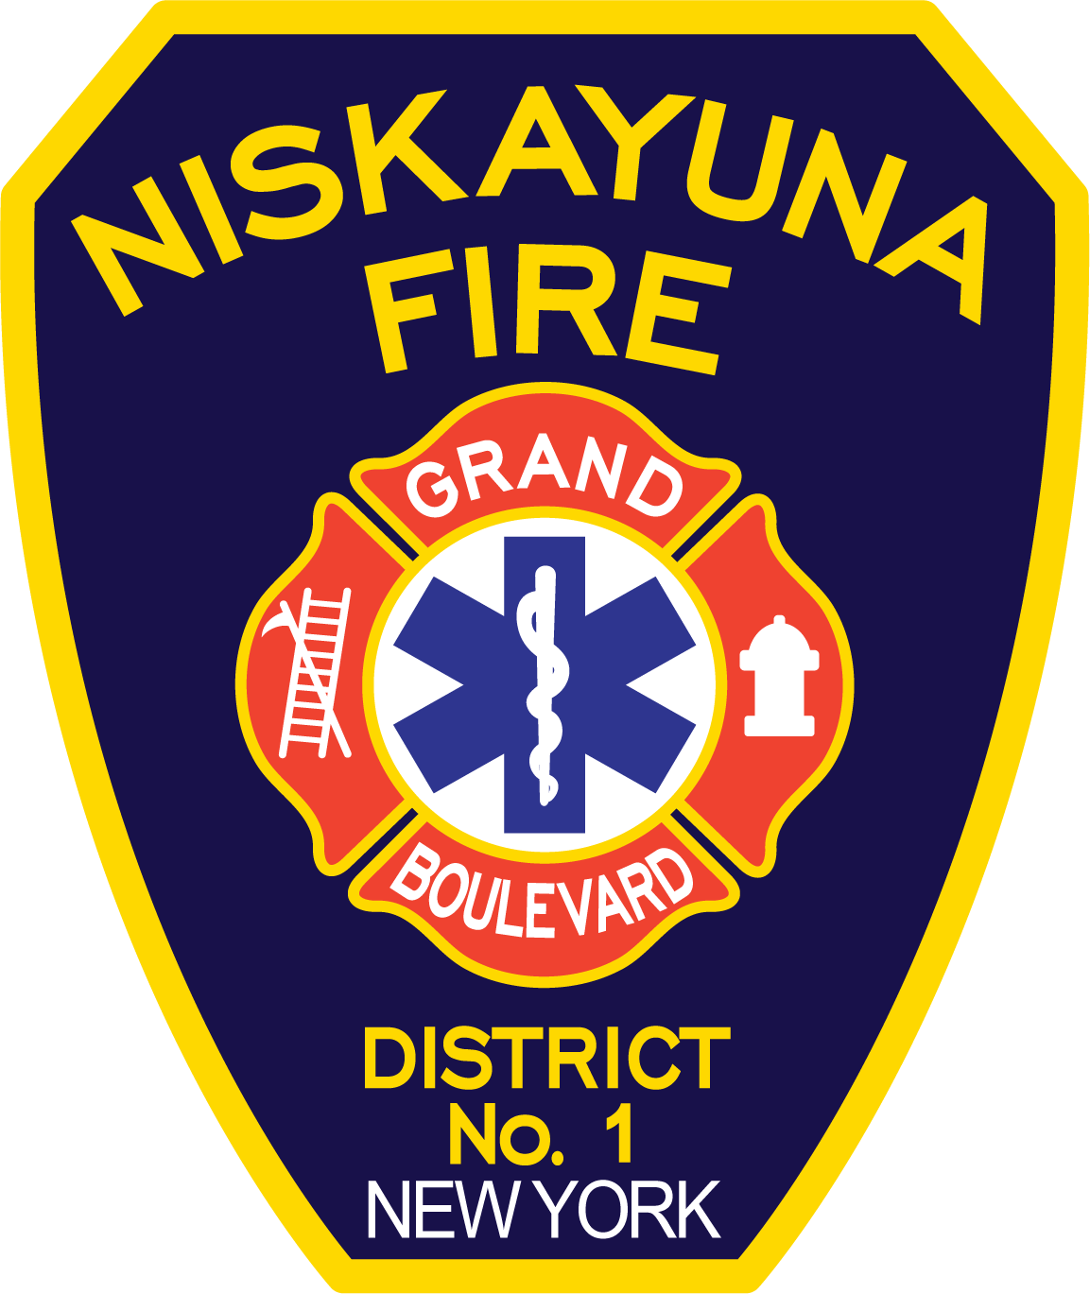

**Strategic Plan**

**2023 to 2028**

# TABLE OF CONTENTS

Welcome Letter 3

Organizational Background 5

Department Mission 7

Vision Statement 7

Organizational Values 7

Recent Department Accomplishment 8

SWOT Analysis Summary 9

Strategic Planning Topics 11

Strategic Planning Topic #1 – Facilities 11

Strategic Planning Topic #2 - Equipment and Apparatus 13

Strategic Planning Topic #3 - Staffing/Structure 14

Strategic Planning Topic #4 - Training 23

Strategic Planning Topic #5 - Professional Development 25

Strategic Planning Topic #6 - Emergency Medical Services 26

Strategic Planning Topic #7 - Policies and Procedures/Rules and Regulations 28

Strategic Planning Topic #8 - Fire Prevention/Education/Pre-Fire Plans 29

Strategic Planning Topic #9 – Communications 30

Strategic Planning Topic #10 – Roles and Responsibilities 31

Appendix A - Vehicle Equipment Replacement Plan 32

Appendix B – Call Volume 33

# WELCOME TO THE 2023 NISKAYUNA FIRE DISTRICT No.1 STRATEGIC PLAN

***SUMMARY***

At this juncture in history, the nature of emergency response and local governance continues to evolve at a rapid pace. As Niskayuna Fire District No.1 (NFD1) and the related Grand Boulevard Fire Company (GBFC) entered our second century of service to the community in 2021, the NFD1 Board of Fire Commissioners created our first ever District Strategic Planning Committee. Its mandate was to assess our Strengths, Weaknesses, Opportunities and Threats and to chart a deliberately planned course for the future of our organization as we work towards our vision of being a leader and innovator in state-of-the-art delivery of emergency services and governance.

The ultimate goal of this strategic plan is to best position NFD1 to sustainably respond in an ever-changing environment so that we consistently achieve our Mission and work towards our Vision through a vibrant combination volunteer/career department that embraces our core values and serves our community.

***PRIORITY STRATEGIC ISSUES***

1. Intelligent planning to mitigate the effects on NFD1 of the national staffing crisis in the fire service and responsibly structure NFD1 to right-size volunteer and career staffing needs for the anticipated call volumes and response types now and into the foreseeable future.
2. Better defined roles and responsibilities documentation. Detailed delegation of tasks and personnel has not kept pace with our growth. We are no longer a provincial department, and we need to better codify structure, professional development, leadership, and roles/responsibilities.
3. Improved communications both internally and externally.

***PROCESS***

**​​☒​** Formation of a strategic planning committee

**​​☒​** Organization-wide survey of stakeholders

**​​☒​** Identification of immediate needs

**​​☒​** Interim actions on immediate needs

**​​☒​** Creation of strategic plan framework

**​​☒​** Delegation of report tasks

**​​☒​** Creation of a DRAFT 5-year staffing plan

**​​☒​** Meetings with stakeholders

**​​☒​** Presentations, revisions, and adoption of 5-year staffing plan

**​​****☒​** Changes to numbers of civil service positions to accommodate 5-year staffing plan

**​​☒​** Creation of DRAFT report

**​​☒​** Public Comment Period

**​​☒​** Presentation, feedback revision and approval of FINAL strategic plan

***COMMITTEE***

The 2021-2023 Strategic Planning Committee consisted of the following individuals:

* Commissioner David J. Pacheco (Committee Chair)
* Commissioner Edward Woehrle
* Fire Chief Dale Lingenfelter
* Volunteer Fire Chief Richard Fritz
* Captain James Vena
* Captain Ted Congdon

***NOTE***

This plan is a living document meant to act as a tangible roadmap to improvement and excellence. It is recommended that the strategic plan be referred to frequently and undergo major revisions every 5 years. Reach out to any member of the Board of Fire Commissioners, Strategic Planning Committee, or command leadership with any questions or to express how you will act to implement the plan in your specific role.

Sincerely,

David J. Pacheco, AIA, NCARB

Strategic Planning Committee Chair

# Organizational Background

The origins of Niskayuna Fire District No. 1 date back to December 2, 1920, when 22 residents were appointed by the Niskayuna Town Board to be the first members of the Grand Boulevard Fire Company. The first “fire station” was a garage located on Myron Street whose owner made available to the fire company for storage of a hand drawn hose cart, a 24’ extension ladder, 8 fire extinguishers, two lanterns, and three nozzles. The fire company responded to 2 alarms during its first year.

As the community grew through the 1920s and the need for service increased, petitions were circulated that resulted in the formation of Niskayuna Fire District No. 1 on March 22, 1932. Niskayuna Fire District No. 1 (NFD 1) primarily encompassed the area currently known as “Old Niskayuna. Over the next few years, the fire district would purchase its first two fire engines and construct their first fire station at 1079 Balltown Road where its core still stands today accompanied by additions in 1947, 1967, and the most recent complete renovation/addition completed in 2012. The fire district itself grew in coverage area including a consolidation with the Aqueduct Fire Company in the 1950s. The Aqueduct fire station was subsequently replaced by a new facility located at 2135 River Road in 1982.

Along with the physical growth of the fire district, its services grew to include emergency medical response. Its first ambulance was purchased in 1979 and NFD 1 established the first paramedic level EMS service in Schenectady County. By 1990 NFD 1 was responding to more than 800 incidents per year out of the two stations with a combination of 11 career firefighter/paramedics and approximately 50 volunteer firefighters and Emergency Medical Technicians.

In the next three decades, Niskayuna Fire District No. 1 would see its population grow and the demand for emergency service response increase along with the scope of those responses. NFD 1 currently provides fire, EMS (Emergency Medical Services), technical rescue, fire prevention and education services to a population of 13,159 year-round residents residing in an area over 10 square miles bordering the Mohawk River and the City of Schenectady. These services are provided from the main fire headquarters located at 1079 Balltown Road and the substation located at 2135 River Road. The department now consists of 18 career firefighter/paramedics, 1 career fire chief and 12 volunteer members responding to 2500 calls for service each year.

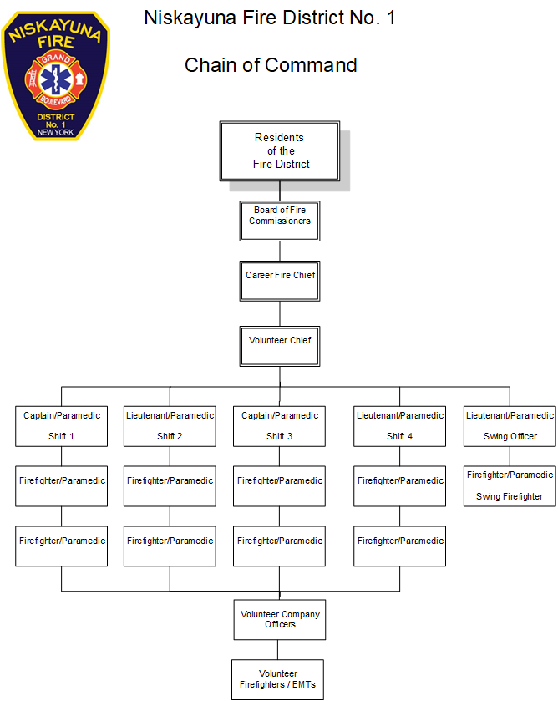

# Department Mission

Niskayuna Fire District No. 1 exists to serve our community by answering the call to preserve life, property, and the environment through safety education, fire prevention services, and a professional response to emergencies affecting our community.

# Vision Statement

Niskayuna Fire District No.1 will improve the quality of life and be recognized by the community as a leader in the state-of-the-art delivery of exceptional emergency response, all-hazard protection, prevention, preparation, community safety, training and responsible local governance for our citizens and visitors.

# Organizational Values

* **Loyalty** - dedication to community and agency

* **Respect** - of others, property, and the environment

* **Teamwork** - throughout the agency, community, and region

* **Compassion** - for those we serve and our fellow responders

* **Honor** - those who have gone before us and the profession we serve

* **Integrity** - doing the right thing

* **Professionalism** - continuous development and application of one’s skills and knowledge to the best of one's ability

# Recent Department Accomplishments

## Equipment and Apparatus

* Developed an equipment PPE replacement plan. All interior qualified firefighters are issued two sets of NFPA (National Fire Protection Association) compliant turnout gear. This allows for immediate cleaning of gear after fires to reduce the cancer risk to our firefighters from the carcinogens present in structure fires.
* Updated all fire attack hose lines and nozzles based on evaluation of available products improving friction loss and flow characteristics.
* Implemented a new 800Mhz county-wide emergency services radio system provided by Schenectady County. The new system allows for enhanced interoperability between law enforcement, EMS, and fire agencies across three counties.
* Incident reporting software was consolidated to reduce redundancy in data entry and enhance reporting capabilities.

## Training - In Service and Other

* All career staff and several volunteer EMS personnel were trained in active shooter hostile event response. This training was followed by full scale region wide active shooter exercises. Three of our career staff were also trained as instructors for the program. We continue to coordinate and train with our law enforcement partners and mutual aid fire and EMS agencies.
* In response to changes in training requirements for career fire chiefs in New York State we have begun training officers for National Certification in Fire Officer I and Fire Officer II.
* Continue to grow our instructor cadre for CPR, Stop-The -Bleed, Rescue Task Force Operations, and numerous state fire training programs.

## Policies and Procedures/Rules and Regulations

* With the recent change to New York State law, we have begun the process of cost recovery for emergency medical services.

## Fire Prevention/Education/Pre-Fire Plans

* Fire prevention program delivery methods were adapted during the response to COVID-19 enabling us to continue providing fire prevention education and training to the students and families in our schools.

## Communications

* Working to develop a more formal communications plan for daily administrative and operational activities to keep internal and external stakeholders better informed.

# SWOT Analysis

**Threats**

**Opportunities**

**Strengths**

**Weaknesses**

In 2022 Niskayuna Fire District No. 1 completed a Strengths, Weaknesses, Opportunities and Threats (SWOT) analysis in preparation for the strategic planning effort. A SWOT analysis evaluates *Internal Organization Factors:* Strengths (S) and Weaknesses (W) and *External Factors:* Opportunities (O) and Threats (T). Surveys were sent to immediate District stakeholders, including District Commissioners as the elected representatives of the public. Responses were greater than 50% and all segments responded including Volunteer members, Career staff, District staff, associated members (such as the auxiliary) and District commissioners.

Respondents could answer anonymously or opt to provide contact information to allow the Strategic Planning Committee to follow up if clarification was needed. Over half of the respondents provided contact information. This allowed for committee members to reach out for more in-depth explanations of certain responses. See for example *Strategic Planning Topic #10 – Roles and Responsibilities* to understand how this process shaped certain elements of the Strategic Plan.

Responses to the SWOT analysis were collated and grouped. In some rare instances, responses were moved to fit in the proper category of the SWOT matrix. For example, if items were obviously an internal Weakness but miscategorized as an external Threat by the respondent. The top five items in each category were placed in a matrix (See below). As these are survey responses and not a committee exercise to create a refined SWOT analysis, the data represents the raw information associated with a broad survey and there are sometimes duplicate items in the different categories or very broad topics. The Strategic Planning Committee worked to understand the results and use them as a guide to undertake the Strategic Plan.

*Strengths – Weaknesses – Opportunities – Threats*

|  |  |
| --- | --- |
| **Strengths**   1. Rapid Response Times 2. Career Staff 3. Paramedics on duty 4. Respect within the Community 5. Excellent Equipment and Facilities | **Weakness**   1. Communication 2. Leadership 3. Lack of Volunteers/ Volunteer Participation 4. Career vs. Volunteer Relationship 5. Insufficient Training / Officer development |
| **Opportunity**   1. Improve Career and Volunteer recruitment. 2. Increase Public Awareness 3. Increase Public Outreach 4. Water Rescue Capabilities 5. Billing for EMS Service | **Threats**   1. Decreasing number of Volunteers 2. Decreased Staffing, recruitment, and retention (Career & Volunteer) 3. Budgetary Constraints 4. Increased Mutual Aid Requests 5. Increasing Call Volume |

# Strategic Planning Topics

**Strategic Planning Topic #1 –** Facilities

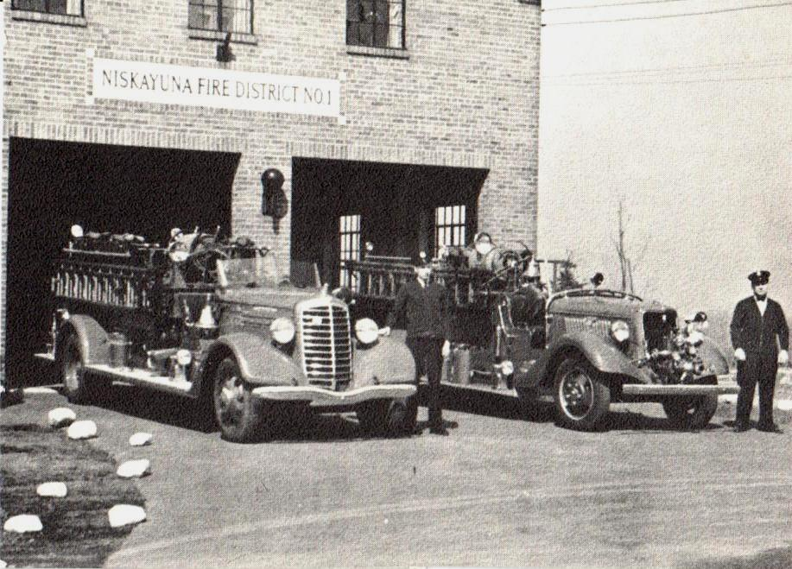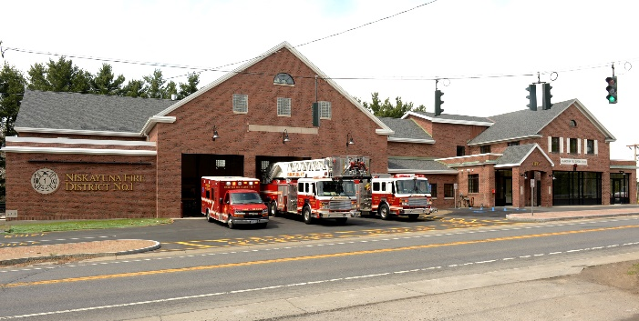

A strategic plan must address the significant assets of an organization and what the plans are for maintaining, improving or replacing them. The District’s largest physical assets are the two fire stations from which emergency response occurs. The main station is located at 1079 Balltown Road and a sub-station is located at 2135 River Road.

The Balltown Road station is a 20,000 square foot facility with a core dating back to 1937. However, this entire structure underwent a substantial addition and comprehensive top-to-bottom renovation in 2012. No significant changes are expected in the next five years. The issue for this facility is continued routine maintenance to allow for current and immediate future needs.

The River Road station on the other hand has had minor renovations, but remains largely as it existed in 1982 when constructed. It is currently under-utilized and at over 40 years old, is in need of considerable modernization and a plan for optimal use. Haphazard storage is a constant struggle at this facility. District washing facilities are located here, but often are unavailable due to apparatus and equipment storage in the bay areas. Future growth is primarily in the north end of the fire district where this station is located. As call volumes increase, consideration will need to be given to how this facility should be utilized. First and foremost, a plan is needed to determine the optimized use of the River Road station. Careful thought is needed to responsibly maximize the value for taxpayers through prudent financial decisions, especially in light of recent inflationary pressures on building costs.

OBJECTIVES:

1. Formulate design solutions with two-year timeline to evaluate current and future needs and five-year objective to complete River Road station improvements in a financially responsible manner. Focus on a training-oriented facility at River Road station with capability to accommodate operational career and/or volunteer duty crews in the future.
2. Improve River Road station washing facilities for district and fire company member vehicles.
3. Improve River Road station storage.
4. Maintain Balltown Road Station.

ACTION ITEMS:

1. Conduct study to define program, scope, and budgets for River Road station facility. (work examples might include gender neutral bathrooms, accessibility, bunk rooms, door replacement, additions, plumbing upgrades, generator replacement, storage improvements and training spaces.)
2. Apply for funding for a portion of state grants and federal grants for fire station construction and improvements as they become available.
3. Clear two rear bay areas and make immediate improvements to district wash facilities.
4. Discard/surplus unused equipment and rearrange training and storage items into the northeast rear bay to improve storage situation.
5. Funding of capital reserve account to prepare for work that needs to be completed.
6. Continue annual facilities assessments and routine maintenance on both facilities.

**Strategic Planning Topic #2 -** Equipment and Apparatus

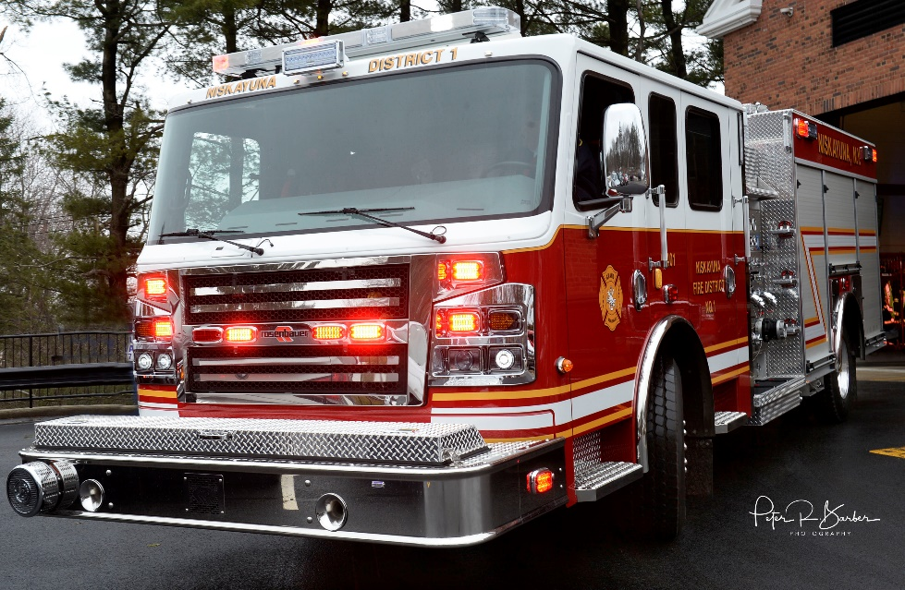

The department has established an apparatus replacement plan which can be found in Appendix A. With the recent escalation of apparatus and equipment costs and lengthened delivery timeframes, re-evaluation of the apparatus replacement plan is needed. A significant portion of our apparatus are at or near their replacement timeframe. Our personal protective equipment replacement schedules are on track and will need to be maintained and updated as needed.

OBJECTIVES:

1. Perform an inventory of all equipment on apparatus.
2. Develop a replacement schedule for all equipment based on expected service life.
3. Ensure reserve accounts and annual budget support the apparatus and equipment replacement schedule.
4. Configure inventory database to support apparatus, equipment, and PPE replacement planning and documentation requirements.
5. Maintain situational awareness of industry equipment and PPE trends with respect to the current and future needs of the fire district.

ACTION ITEMS:

1. Update the existing apparatus replacement plan to reflect recent cost escalation and add fields to reflect ordering lead times.
2. Establish apparatus workgroup to make recommendations to the board for purchases by fall of 2023.
3. Assign staff to complete a detailed inventory of all equipment on apparatus.
4. Configure Zoll inventory database to support the objectives noted above.

# Strategic Planning Topic #3 - Staffing/Structure

NFD1 is a combination volunteer/career organization. Our dedicated and professional career and volunteer staff stand ready and remain committed to protecting our community 24 hours a day, 7 days a week, 365 days a year. The District remains committed to a strong combination organization as the best of both worlds. Our career personnel provide quick response from a continuously staffed facility and our volunteer members provide cost-effective additional responders for large or multiple incidents. In addition, volunteers have traditionally served as a pool of qualified candidates for open career positions.

The staffing plan presented is not meant to diminish volunteer participation. Rather it is meant to provide new mechanisms for increased volunteerism while acknowledging the need for new and replacement career staff as call volumes rise. A nationwide decline in volunteer fire service membership accompanied by an increasing average age of volunteer membership is a known trend. Additionally, fewer individuals are pursuing civil service positions which is resulting in difficulty filling vacant and new career positions. A recent report by the Network of Schools of Public Policy, Affairs and Administration found that between 2001 and 2017 the number of college graduates going into local, state and federal civil service jobs dropped 15%. NFPA in their 2022 report *US Fire Department Profile 2020* notes that the number of US firefighters decreased 4% in one year and overall are at their lowest levels since 1991. In addition, over the last 20 years the number of firefighters 50-59 years of age and over 60 years of age has increased significantly while those 16-19, 20-29, 30-39 and 40-49 years of age have decreased markedly in the same period. The trends are clear. Requests for services in the District have been increasing annually since the department was organized in 1920. Large number of career personnel eligible for or nearing retirement age and there is need for administrative support of department administration and operations.

We need to cover staffing losses, increase volunteer participation, right-size staffing for existing and projected call volume, allow for planned promotion, backfill, and personnel development and undertake necessary updates with Civil Service to accommodate our staffing plan.

OBJECTIVES:

1. Create a 5-year staffing plan.
2. Use staffing plan to identify necessary changes to civil service position number and requirements.
3. Enhance recruitment and retention efforts for volunteer and career staffing.
4. Update current personnel evaluation program to include all personnel and solicit feedback.
5. Develop programs and incentives to recognize staff performance.
6. Track trends in requests for service.

ACTION ITEMS:

1. Implement 5-year staffing plan.
2. Coordinate with civil service to make necessary changes to civil service position numbers and requirements to match staffing plan needs.
3. Evaluate and implement recruitment opportunities to attract volunteer members and those wishing to pursue a career as a first responder.
4. Encourage a duty crew model for volunteers to allow defined commitments for new volunteer members. Aggressively recruit on the duty crew model.
5. Develop and implement recruitment and retention plan for career staff.
6. Amend the Grand Boulevard Fire Company Constitution & Bylaws to accommodate duty crews and different membership by enhancing flexibility of membership requirements and efficient use of member time.
7. Utilize website and social media for recruitment. Ensure this information is up to date. For example, a recent review of the website shows a FIREFIGHTER/PARAMEDIC exam announcement listed under NEWS that is a year old.
8. Create personnel evaluation, growth and feedback program.
9. Review current staff and member recognition efforts and identify additional opportunities.
10. Continue to collate request for service data. Start to post call trends on website.

# Strategic Planning Topic #4 - Training

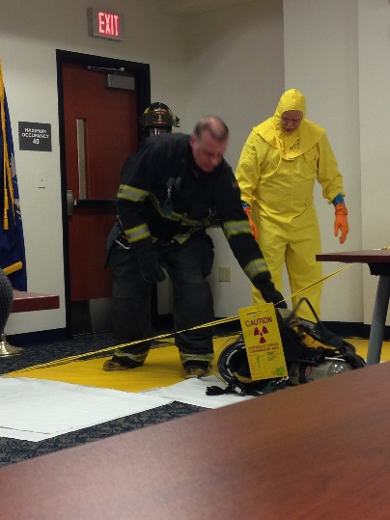

As fire departments take on more responsibilities and duties while becoming an all-hazard mitigation department more training and expertise is often needed. Training should be conducted daily within the department which will be led by the Company Officer. Specialized training will be conducted by the department training officer or outside the department instructors. Each firefighter, career or volunteer, will be held to the same training standard. Training will increase the value of the fire fighter in the community as well as the safety within the department. The goal will be to continue the training program and promote training that leads to professional growth of the members.

OBJECTIVES:

1. Provide the Company Officers with the means to conduct in-service training with their shift and volunteer duty crew members.
2. Continue having the training officer schedule and teach standard training exercises, with all department members, to establish consistency and proficiency in emergency response evolutions and skills.
3. Update training standards for all members of the department.
4. Increase the member knowledge and skill levels to enhance their value to the department and the community.

ACTION ITEMS:

1. Require all personnel in leadership positions take Fire Instructor/Officer training appropriate for their position.
2. Document and post position-based training requirements.
3. Conduct the training and receive feedback.
4. Complete training records data entry and hold department members accountable for completing all assigned training.
5. Integrate new materials and technologies into training.
6. Conduct an evaluation of current training programs and department needs in relation to PESH/OSHA and New York State standards and mandates.
7. Constantly improve the training program based on changing needs and member feedback.
8. Institute changes to have mentorship program consistent from shift to shift. This may require a more organized checklist specific for mentors to ensure that each shift is providing the same opportunities and experience. This will become critical as duty crews become regular.

# Strategic Planning Topic #5 - Professional Development

The future of the department comes from creating those prospective leaders today. Creating those leaders is a process that includes training, education, self-development, and experience. There needs to be a basic framework for the desired certifications, education level, and experience for each rank. These need to be published and made available so future leaders can understand them prior to being promoted. Opportunities can be created for personnel to obtain experience by letting them act in the roles they want to pursue, and role play through training. Career advancement is not just about on the job training but rather a pathway of demonstrating knowledge, skills, and ability along the way. The goal of management is to help define those career paths and help personnel understand those paths and how to pursue them.

OBJECTIVES:

1. To list preferred certifications, level of education, experience, and self-development for each rank.
2. To change the culture of being put into a position and then trained to fill that position to one of training for a position or rank one wishes to achieve.

ACTIONS:

1. Create and develop job descriptions, list preferred certifications, level of education, experience, and self-development for all fire department positions.
2. Develop minimum standards for each departmental position.

# Strategic Planning Topic #6 - Emergency Medical Services

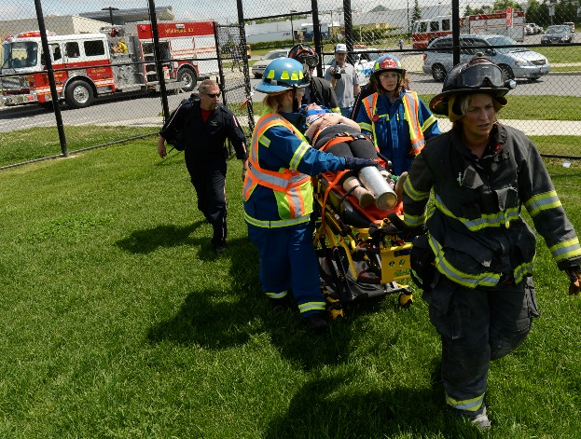

Niskayuna Fire District No. 1 has a proud history in EMS becoming the first fire department-based Advanced Life Support paramedic service in Schenectady County in 1979. We have adapted to meet the needs of our community residents through severely challenging times. Some examples are Covid-19, and Anthrax, Ebola, and Monkeypox outbreaks as well as assisting New State and Local partner agencies in disaster response. For example, we responded an ALS ambulance with firefighter/paramedics to the 9/11/01 attack on the World Trade Center and to the 2006 Delaware County Floods.

Over the last 5 years, NFD 1 has experienced an 8% growth in EMS call volume while experiencing a 28% loss in total responders. This Strategic Plan is crucial to addressing that growth and shortage respectively. Our dedicated and professional career and volunteer staff stand ready and remain committed to protecting our District through personal and professional development, and most importantly through the faith and support of our residents. Over the next 5 years, we will continue this tradition by meeting the following objectives.

OBJECTIVES:

1. Maintain High Quality of Service.
2. Maintain high educational standards for career and volunteer personnel.
3. Evaluate and implement/maintain appropriate EMS Resource Utilization to meet the service demand.

ACTION ITEMS:

1. Research the feasibility and impact of adding EMT’s to supplement Paramedic’s.
2. Research the feasibility of incorporating Telemedicine into EMS care modalities.
3. Maintain service standards and identify educational needs through Continuous Quality Improvement. Issues identified will be analyzed to determine if there is an educational deficiency and/or the need for engineering controls.
4. Establish an EMS equipment standardization program that includes the following components:
   * Continuous evaluation of the performance of medical equipment used by prehospital providers.
   * Evaluate and implement an inventory control system.
   * A technology refresh cycle for all durable medical equipment.
   * Exploration of funding opportunities for the purchase of equipment.
5. Review billing practices to ensure they are in-line with industry standards.

# Strategic Planning Topic #7 - Policies and Procedures/Rules and Regulations

As the landscape of Fire and Emergency Service changes, Niskayuna Fire District No. 1 and the Grand Boulevard Fire Company will grow and adapt to ensure relevancy and consistency in policies, procedures, rules, and regulations department wide. State and Federal Laws change, therefore, staying up to date is an important business objective. Additionally, as data emerges, and best practices are released, Standard Operating Procedures (SOP's) and Standard Operating Guidelines (SOG's) will need to be updated or created to assist Fire Officers in in decision making for emergent/hazardous incidents.

OBJECTIVE:

1. To ensure Niskayuna Fire District No. 1 and Grand Boulevard Fire Company are up to date and compliant with all relevant policies, procedures, rules and regulations as required by law and industry best practice.

ACTION ITEMS:

1. Evaluate the current rules and regulations to ensure compliance with local, State and Federal Law.
2. Audit the current rules and regulations for gaps in workplace policies recommended or required by State and/or Federal Law.
3. Update current operational response SOP/SOG's to include the latest industry standard practices.
4. Create new SOP/SOG's as needed for emerging threats (i.e. Lithium Battery Fires).
5. Determine the feasibility and relevance of employing a 3rd party vendor to assist with auditing and updating all necessary rules, regulations, policy and procedures to the appropriate standard or law.

# Strategic Planning Topic #8 – Fire Prevention/Education/Pre-Fire Plans

One of the most critical services provided by Niskayuna Fire District No. 1 is that of fire prevention. Fire prevention includes education of the community in preventing fires, how to act when faced with a fire, and ensuring that the homes and businesses in our community are safe for occupancy and their intended use. Currently NFD 1 provides free installation of smoke and CO alarms, home safety surveys, senior fire safety education, fire safety education in our schools, CPR training for numerous businesses and school staff, hands only CPR training for all high school juniors, fire safety inspections in all commercial occupancies in NFD 1, and numerous tours and public outreach efforts.

OBJECTIVES:

* + - * 1. Continue to support current fire prevention initiatives.
        2. Enhance collaboration with neighboring agencies on fire prevention efforts.
        3. Expand educational deliveries to include “Stop the Bleed”, cooking safety, and public CPR training opportunities.
        4. Capitalize on social media outlets to convey fire prevention and increase public awareness.
        5. Continue building relationships with town building and planning departments to increase participation in the code enforcement and plan review process.

ACTIONS:

1. Develop fire safety education programs for middle and high school students.
2. Increase fire prevention activities at community events such as Niska-Day and Farmer’s Markets.
3. Investigate the feasibility of creating a Community Risk Reduction Program as outlined in *NFPA 1300 Standard on Community Risk Assessment and Community Risk Reduction Plan Development*.
4. Establish policy and procedures for use and frequent updating of social media, website, and traditional media outlets to enhance our community outreach and education.**Strategic Planning Topic #9 –** Communications

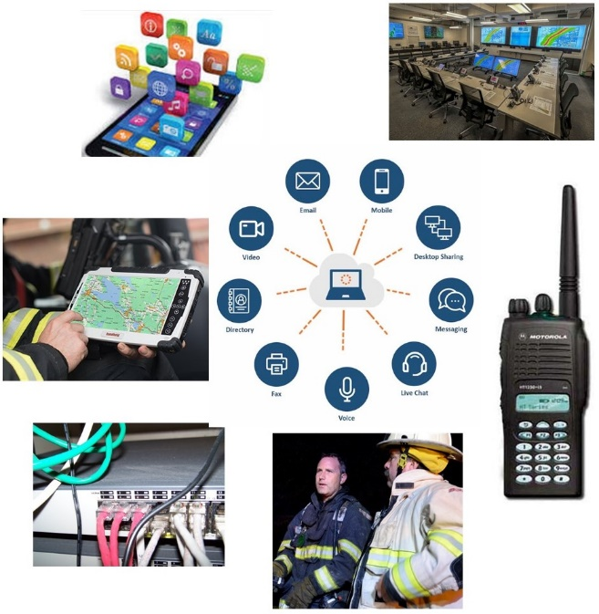

Inter-department communication occurs on a regular basis between the Fire Department and the Board of Fire Commissioners, Building Department, and other department heads along with the Town Government. The department is trying to expand upon its usage of social media outlets.

The goal is to continue building communication between all areas of the town, the department and the public.

OBJECTIVES:

1. Improve communication within the department.
2. Create shared strategies on shared objectives with other town departments.
3. Develop focus group to develop the path of the department.
4. Promote department to the public.

ACTIONS:

1. Establish and communicate appropriate applications for different messages.
2. Create an SOP guiding members where to find specific types of information.
3. Establish a member preferred email for every member without a department issued email address and hold all members accountable to read and respond to all messages.
4. Establish a standard mechanism for regular communication among the leadership of career, volunteer, and auxiliary members.
5. Continue to utilize traditional media outlets, social media, and public outreach events to communicate with the public and promote the department.
6. Hold regular officers' meetings, holding officers accountable to facilitate communications with Firefighters keeping them up to date with the latest information.

# ￼￼Strategic Planning Topic #10 – Roles and Responsibilities

Follow-up discussions with SWOT analysis respondents occurred to identify why “Leadership” was frequently cited as a weakness. Such a word carries with it a broad spectrum of meanings and it does not necessarily describe whether the feedback is directed at the level of district leadership, operational leadership, or individual leadership. A substantial majority of respondents who were willing to expand on their responses, indicated that the leadership weakness revolves primarily around defining Roles and Responsibilities. What is the expectation of and from leadership, where do authorities begin and end, what is each person’s function and how are they empowered to fulfill their role. There is a desire for renewed discussions on Roles and Responsibilities along with a clearly written outline of the expectations, authority and accountability of each person or job position. When the district was smaller, this was easier to implement in a less formal manner. As we have grown, there is a need to better define and adhere to established Roles and Responsibilities. Not only will this clarify the expectations of leadership, but it will also allow development of future leaders by establishing a career growth model where people know precisely what they are responsible for in each role and the skills that must be mastered.

OBJECTIVES:

1. Formalize Roles and Responsibilities (In written format) of all positions by 2025.
2. Clearly define expectations and metrics for assessment including a feedback loop for leaders.
3. Empower individuals to fulfill their roles.

ACTIONS:

1. Evaluate and develop Roles and Responsibilities and create a modernized Roles and Responsibilities manual in coordination with relevant stakeholders.
2. Define expectations and create a system for measuring how successful individuals are and the district as a whole is in fulfilling Roles and Responsibilities. This is to include an effective and reliable feedback loop to address issues.
3. Create an environment that empowers individuals and establish a minimum annual Roles and Responsibilities meeting with each position within the district.

# Appendix A - Vehicle Equipment Replacement Plan

**Apparatus**

|  |  |  |  |
| --- | --- | --- | --- |
| Type & ID Number | Year | Make & Model | Anticipated Replacement |
|  |  |  |  |
| Car-409 | 2019 | Chevy Tahoe | 2028 |
| Car-408 | 2018 | Chevy Tahoe | 2027 |
| Car-407 | 2018 | Chevy Tahoe | 2027 |
| Utility-4051 | 2018 | Chevy Silverado | 2027 |
| Utility-4052 | 2005 | Chevy Silverado | 2023 |
| Ambulance-4080 | 2016 | GMC / Wheeled Coach | 2028 |
| Ambulance-4081 | 2014 | GMC / Wheeled Coach | 2026 |
| Ambulance-4082 | 2010 | GMC / Wheeled Coach | 2023 |
| Engine-4021 | 2016 | Rosenbauer | 2036 |
| Engine-4022 | 2003 | American LaFrance | 2023 |
| Truck-4075 | 1999 | American LaFrance | 2024 |

Actual replacement date will be based on determination of need considering vehicle condition and funding ability.

# Appendix B – Call Volume

